**PARIVEDANA**

**grievances Portal**

**MINI PROJECT – I**

**SYNOPSIS**



**SUBMITTED TO: -** **SUBMITTED BY: -**

Mr. Mandeep Singh Chhaya Chaudhary

(Technical Trainer) Roll No. 201500200 (A-17)

Section : A Year : 3rd

**ACKNOWLEDGEMENT**

I am delighted to present the summary of our B.Tech mini project II, which was carried out during our third year of B.Tech studies. This project is a testament to the motivation, drive, and technical assistance provided by numerous individuals. I would like to express my sincere appreciation to **Mr. Mandeep Singh(Technical Trainer)**  for creating a supportive environment for us to develop this project. His constant encouragement and guidance helped us channel our abilities towards a constructive goal.

His dedication, attention to detail, and perseverance have been a consistent source of inspiration for us. We are confident that he will provide us with invaluable insights and feedback throughout the different stages of the project, and also educate us on the latest industry-specific technologies. We would also like to extend our gratitude to all the faculty members of the department for their kind guidance and cooperation, which contributed to the success of this project.

**CHHAYA CHAUDHARY**

201500200 (A-17)

**DECLARATION**

I hereby declare that the work which is being presented in the project synopsis “***PARIVEDANA***” in partial fulfillment of the requirement for project is an authentic record of our work carried under the supervision of Mr. Mandeep Singh during session **2022-23**.

Mentor: Mr. Mandeep Singh (Technical Trainer)

Sign: __________

**CONTENTS**

Acknowledgement

Declaration

1. Introduction

1.1 Objective

1.2 Motivation

1.3 Problem Statement

2. Software Requirement

2.1 Hardware Requirements

2.2 Software Requirements

3. Project Description

4. Working

5. Implementation

6. References

**INTRODUCTION**

**PARIVEDANA** is a grievances portal created to file/inform the grievances of individuals to respective authorities an. It allows the authorities to receive those grievances and update the status. Individuals also can keep track of their application.

**OBJECTIVE :**

The objective of the Grievances Portal project was to create a web application that enables individuals to report grievances related to various sectors like education, health, services and provide a platform for effective management and resolution of these grievances.

**MOTIVATION :**

The motivation behind this project was to address the challenge of managing and resolving grievances efficiently, which often requires a significant amount of time and resources. By creating a platform that facilitates the reporting and resolution of grievances, the project aimed to streamline the process and ensure timely and effective resolution.

**Problem Statement: Grievances Portal using MERN Stack**

The process of reporting and resolving grievances related to various sectors such as healthcare, education, public services, and more can often be time-consuming and inefficient. There is a need for a platform that facilitates the reporting and resolution of grievances in a timely and effective manner.

The Grievances Portal project aimed to address this problem by creating a web application that enables individuals to report grievances easily and provides a platform for effective management and resolution of these grievances. Additionally, the project aimed to ensure the security and privacy of user data, which is a significant concern in the context of online grievance reporting.

**SOFTWARE AND HARDWARE REQUIREMENTS**

* HTML CSS JavaScript
* A Code Editor
* Computer with Express, Node.JS , Mongo DB
* Windows Operating System
* Browser
* Git Bash
* A Computer with Minimum 8GB RAM

**PROJECT DESCRIPTION**

The Grievances Portal is a web application that provides a platform for individuals to report grievances related to various sectors such as healthcare, education, public services, and more. The project involved designing and developing the portal's user interface using React.js, creating and integrating RESTful APIs with the backend, and implementing user authentication and authorization using JSON Web Tokens (JWT).

The project team ensured the security and privacy of user data by implementing various security measures such as encrypting sensitive user data, using HTTPS protocol, and validating user inputs to prevent SQL injections and cross-site scripting (XSS) attacks.

The portal includes features such as real-time notifications, user roles, and an admin dashboard to manage and resolve grievances efficiently, making it easy for users to report grievances and track their status. The project aimed to provide a user-friendly and efficient platform that enhances the grievance reporting and resolution process.

The project also provided an opportunity for the team to enhance their skills in MERN stack development, RESTful API creation, and web security while delivering a high-quality and user-friendly product that addresses the critical social issue of managing and resolving grievances effectively.

**WORKING**

* User Interface: The user interface of the portal is designed using React.js and includes features such as a home page, grievance reporting page, user login and registration, profile , and an admin dashboard.
* RESTful APIs: The backend of the portal is built using Node.js and Express.js, and RESTful APIs are created for various functionalities such as user authentication, grievance reporting, and admin management.
* User Authentication and Authorization: User authentication and authorization are implemented using JSON Web Tokens (JWT), ensuring that only authorized users can report grievances or access the admin dashboard.
* Grievance Reporting: Users can report grievances related to various sectors by filling out a form that includes details such as the type of grievance, date, location, and description.
* Grievance Tracking: Users can track the status of their grievances using real-time notifications and a grievance tracking system, which enables them to know the progress of their grievances.
* Admin Management: The admin dashboard allows authorized personnel to manage grievances efficiently by assigning them to appropriate authorities, tracking their status, and resolving them within the stipulated time.
* Web Security: Various security measures such as encrypting sensitive user data, using HTTPS protocol, and validating user inputs are implemented to ensure the security and privacy of user data.

Overall, the Grievances Portal provides a user-friendly and efficient platform for reporting and managing grievances, ensuring timely and effective resolution of grievances.

**IMPLEMENTAION**

* Project Planning:I planned the features and functionalities of the portal, created a project timeline, and identified the necessary resources and tools required for the project.
* User Interface Design: I designed the user interface of the portal using React.js, including the home page, grievance reporting page, user login and registration, and an admin dashboard.
* Backend Development: The backend of the portal was developed using Node.js and Express.js, and RESTful APIs were created for various functionalities such as user authentication, grievance reporting, and admin management.
* User Authentication and Authorization: User authentication and authorization were implemented using JSON Web Tokens (JWT) to ensure that only authorized users could report grievances or access the admin dashboard.
* Grievance Reporting: A form was created for users to report grievances related to various sectors, including details such as the type of grievance, date, location, and description.
* Grievance Tracking: Real-time notifications and a grievance tracking system were implemented to allow users to track the status of their grievances and know the progress of their complaints.
* Admin Management: An admin dashboard was created to enable authorized personnel to manage grievances efficiently by assigning them to appropriate authorities, tracking their status, and resolving them within the stipulated time.
* Web Security: Various security measures such as encrypting sensitive user data, using HTTPS protocol, and validating user inputs were implemented to ensure the security and privacy of user data.
* Testing and Deployment: The portal was tested extensively to identify and fix any bugs or issues, and the project was deployed to a server for public access.

Overall, the implementation of the Grievances Portal using MERN stack involved careful planning, design, and development of various functionalities, while ensuring the security and privacy of user data.

**DATA FLOW DIAGRAM**

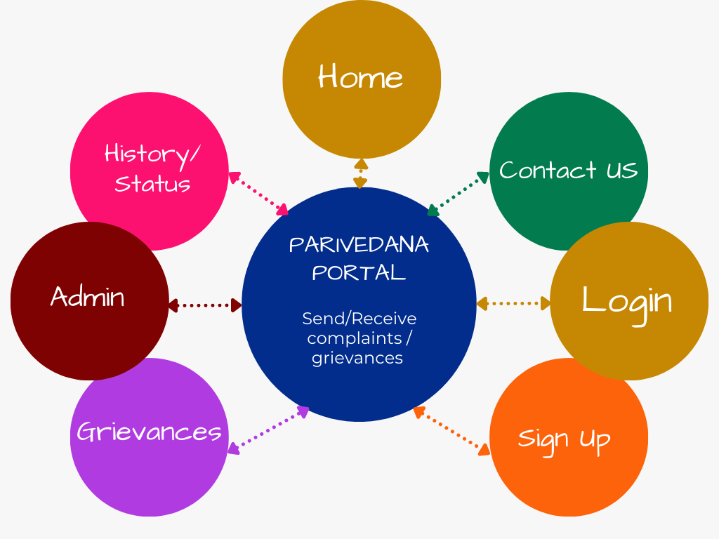

**REFERENCES**

* MERN Stack Tutorial by Traversy Media: <https://www.youtube.com/watch?v=7CqJlxBYj-M>
* Building MERN Stack CRUD Web Application by TutorialsPoint: <https://www.tutorialspoint.com/building-mern-stack-crud-web-application>
* React.js Documentation: <https://reactjs.org/docs/getting-started.html>
* Node.js Documentation: <https://nodejs.org/en/docs/>
* Express.js Documentation: <https://expressjs.com/en/starter/installing.html>
* MongoDB Documentation: <https://docs.mongodb.com/>
* JSON Web Token (JWT) Documentation: <https://jwt.io/introduction/>
* Stack Overflow: <https://stackoverflow.com/>